**MAD-1 Project Report  
Household Services App V1**

**Student Details:**

* **Name:** Rishi Jain
* **Student ID:** 21f1002476
* **Course:** Household Services App V1 – MAD-1 Project

**Project Details**

* **Project Title:** Household Services App V1 – MAD-1 Project
* **Problem Statement:**  
  The project aimed to build a web application for managing household services, providing tailored features for customers, professionals, and administrators.
* **Approach to the Problem:**  
  The problem was addressed by creating a role-based system with distinct dashboards for each user type, a relational database for seamless data handling, and integrating analytics for operational insights.

**Frameworks and Libraries Used**

* **Backend:** Flask (Python Framework)
* **Frontend:** Jinja2 Templates, Bootstrap 5
* **Database:** SQLite, FlaskSQLAlchmey,
* **Authentication:** Flask-Login
* **Other:** Apscheduler, datetime, Flask-WTF etc.

**Drive Link -***https://drive.google.com/drive/folders/186b6NaTd0nuU0HX64UnCit1enf4ziVYP?usp=sharing*

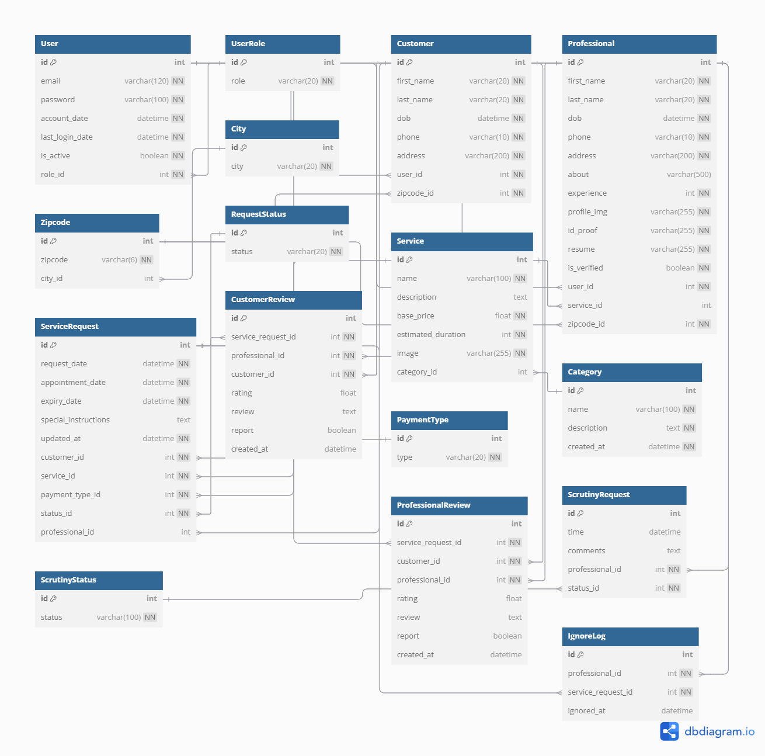**ER Diagram**